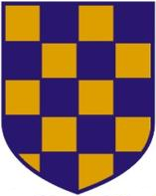 | 2026 SURREY MASTERS CHAMPIONSHIPS  TEAM NAMES NOMINATION FORM  COMPETITION DATE: Saturday 27th June 2026  ENTRY CLOSING DATE: Tuesday 23rd June 2026

Event | 12 / 13 / 14 | Men’s / Ladies / Mixed | Medley Relay
 | 19 / 20 / 21 | Men’s / Ladies / Mixed | Freestyle Relay
CLUB: |  | Team | A / B / C
Contact name: |  | Age Group: | Senior 120-159  160-199 200-239  240-279 280+
Swimmer | Name | DOB | Age (31st Dec 2026)
1
2
3
4
Total Ages

