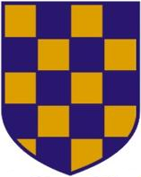 | 2024 SURREY MASTERS CHAMPIONSHIPS  SUPPLEMENTARY TEAM NAMES FORM
 | Competition date: | Saturday 29th June 2024
 | Relay Closing Date: | Monday 24th June 2024

For Team Managers only:
Please, only use this form to nominate any swimmers who are likely to swim in your relay teams but are NOT entered in individual events:

Club:
Swimmer Names | Swim England number: | Year of Birth: | Age (at 31/12/24):

