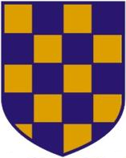 | 2024 SURREY MASTERS CHAMPIONSHIPS  TEAM NAMES NOMINATION FORM  COMPETITION DATE: Saturday 29th June 2024  ENTRY DATE: Monday 24th June 2024

Event | 19 / 20 / 21 | Mens / Ladies / Mixed | Medley Relay
 | 30 / 31 / 32 | Mens / Ladies / Mixed | Freestyle Relay
CLUB: |  | Team | A / B / C
Contact name: |  | Age Group: | Senior 120-159  160-199 200-239  240-279 280+
Swimmer | Name | DOB | Age (31st Dec 2024)
1
2
3
4
Total Ages

