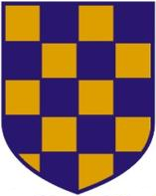 | 2022 SURREY MASTERS CHAMPIONSHIPS  SUPPLEMENTARY TEAM NAMES FORM
 | Competition date: | Saturday 25th June 2022
 | Relay Closing Date: | Sunday 19th June 2022

For Team Managers only:
Please, only use this form to nominate any swimmers who are likely to swim in your relay teams who are NOT entered in individual events:

Club:
Name | ASA number: | Year of Birth: | Age (at 31/12/22):

