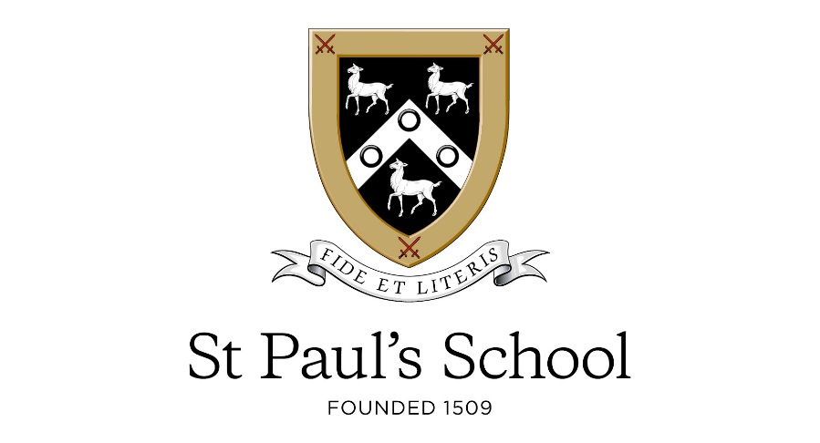

St Paul’s is a selective Independent Day School for boys aged 13-18, occupying a superb 45-acre site on the south bank of the Thames, west of Hammersmith Bridge. St Paul’s School excels academically at both A level and GCSE, with some of the highest national scores, but it is the work beyond the curriculum that excites both students and teachers alike.

Water Polo Coach
Commencing ASAP

St Paul’s Aquatics department are looking to recruit a pro-active and enthusiastic Water Polo Coach. Previous experience of working as a water polo coach is essential, as well as an up-to-date lifeguard qualification. Good time management and an ability to provide constructive feedback is also required. The successful candidate must hold an ASA Level 1 swimming teaching qualification as a minimum and demonstrate an appropriate level of technical knowledge.

The successful candidate will be employed on a casual contract and paid for the hours they work per week.

Further details and an application form can be obtained from the School’s website: www.stpaulsschool.org.uk via the ‘Vacancies’ link, or by email from humanresources@stpaulsschool.org.uk

The closing date for all applications is midday on Monday 24 February 2020
Interviews will take place on Monday 2 March 2020

St Paul’s School is committed to safeguarding and promoting the welfare of children and young people and expect all staff and volunteers to share this commitment. Applicants will be required to undergo child protection screening appropriate to the post including checks with past employer and the Disclosure and Barring Service. St Paul’s School is an equal opportunities employer.

St Paul’s School, Lonsdale Road, London SW13 9JT

